ATIC Accessibility
To support the accessible community in making informed travel decisions for their individual needs

This report prepared for:
Business name: | Kinglake Forest Adventures Camp
Address: | 1419 Whittlesea-Yea Rd
Town: | Kinglake West
Contact for enquiries: | Colin French
Contact Number: | 03 57865230
Contact Email: | info@kfacamp.com.au
Website: | www.kfacamp.com.au
Date: | 2025-08-06 11:05

ATIC Accessibility
The following pages provides travellers with information on the businesses facilities and amenities which aims to support the traveller to make an informed decision on whether the business is suitable for their individual needs.
OVERVIEW 4
Business Overview 4
Bookings 4
Emergency Management 4
Communications 5
Guide Dog and Service Animals 5
GENERAL 6
Pre-arrival, arrival and reception 6
Car Park and Access amenities 6
Entry 6
Internal Spaces 6
Public areas 7
External Paths 7
Steps 7
Ramps 7
Public Toilets/Adult change facilities 7
ACCOMMODATION 9
Bedrooms 9
Room Amenities 9
Bathrooms 10
COMMON AREAS 11
Parks and gardens 11
FOOD AND DRINK 13
Dining Spaces 13
ADVENTURE ACTIVITIES 15
Report Disclaimer 17

OVERVIEW

Business Overview

The business has the following products/services available
- Accommodation
- Food and Drink
- Adventure

Our business caters for the following disability types:
- Food allergies or intolerances
- Cognitive or people on the Autism Spectrum
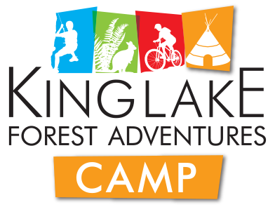

Bookings

The business offers the following methods for bookings and enquiries:
- Phone
- Email

Emergency Management
- Emergency and evacuation procedures are explained on arrival
- Exit signs are clear and easy to see
- Exit access is free and clear at all times
We ensure exit access is free and clear at all times by:
All exits are free and clear of any obstacles
- Exits and access to exists are greater than 900mm
- Exit doors are able to be opened by all occupants
- Exits to the emergency evacuation point does not include stairways
- The evacuation point is clearly marked by a sign
The business identifies guests who need additional assistance should an emergency occur by:
All of our guests who need additional assistance are identified before their stay with us and then on arrival
The procedure for assisting guests who need assisted rescue is:
Our staff have already identified any guests who need extra assistance and these guests are prioritized within our Emergency Management plan
- Guests with disabilities are noted in the guest log book for emergency and evacuation purposes

Communications
- Our business offers the following alternative communication methods
- Plain English

Not specified
- There is easy to read signage and information (e.g. menus and emergency information)

Guide Dog and Service Animals
The business provides the following services for services animals:
Not specified

GENERAL

Pre-arrival, arrival and reception
The business has the following in place to support guests during pre-arrival, arrival and reception
- Information and maps are available in written form
- In addition, the following further information can assist guests:
We do not have long queues for our guests. &nbsp;We do provide a large indoor space where guests can rest and recuperate if required.

Car Park and Access amenities
The business has the following Car Park and Access amenities
- Level or ramped access from the car park to the entrance

Entry
The business has the following amenities/systems in place for entry
- A drop off point close to the entrance
- A path of access to the building is clear of obstruction
- Signage is written in a contrasting colour
- The entry door is a minimum of 850mm wide
- The entrance sill is less than 13mm
- There a clear space of at least 1500mm x 1500mm in front of all doors.
- The entrance door mats have a thickness less than 13mm and a width of 7500mm or greater

Internal Spaces
- Clear and unobstructed routes through and between buildings
- Interior walls are matte or low sheen
- Floors, walls, counters and furniture are of contrasting colours
- Any protruding or overhanging obstructions are at least 2meters above the floor or are protected
- Tableware/glassware contrast with the table surface or table cloth
- Floor surfaces are hard or short pile carpet
- Seating is available for guests unable to stand for long periods
- Accessible facilities are clearly signed and visible from all areas
- All corridors greater than 900mm

Public areas
The public areas have the following amenities in place
- Seating

External Paths
External paths of travel have the following amenities are in place
- Pathways are wider than 900mm
- There 3 successive steps or less on any path or at any doorway

Steps
Steps have the following amenities are in place
- There are steps.
- The underside of all staircases are enclosed or protected to a height of at least 2 metres
- Handrails fitted to all open sets of steps

Ramps
Ramps have the following amenities are in place
- There are ramps.
- All fixed ramps are 1:14 or less
- Hand rails are fitted
- Long ramps (more than 10m) are 1:20 or less

Public Toilets/Adult change facilities
Public Toilets/Adult change facilities have the following amenities are in place
- There is an accessible toilet for public use
- The door is at least 850mm wide
- There is a minimum of 850mm beside the toilet
- Handrails are fitted
- The toilet seat is 460mm above the floor
- The toilet seat of a contrasting colour to the floor
- The toilet seat is460mm above the floor

ACCOMMODATION

Bedrooms
The bedrooms have the following facilities/amenities in place
- There are 8 rooms available to guests who use a wheelchair
- Bedroom furniture can be re-arranged on request

Not specified
  - Layout of room Image(s)
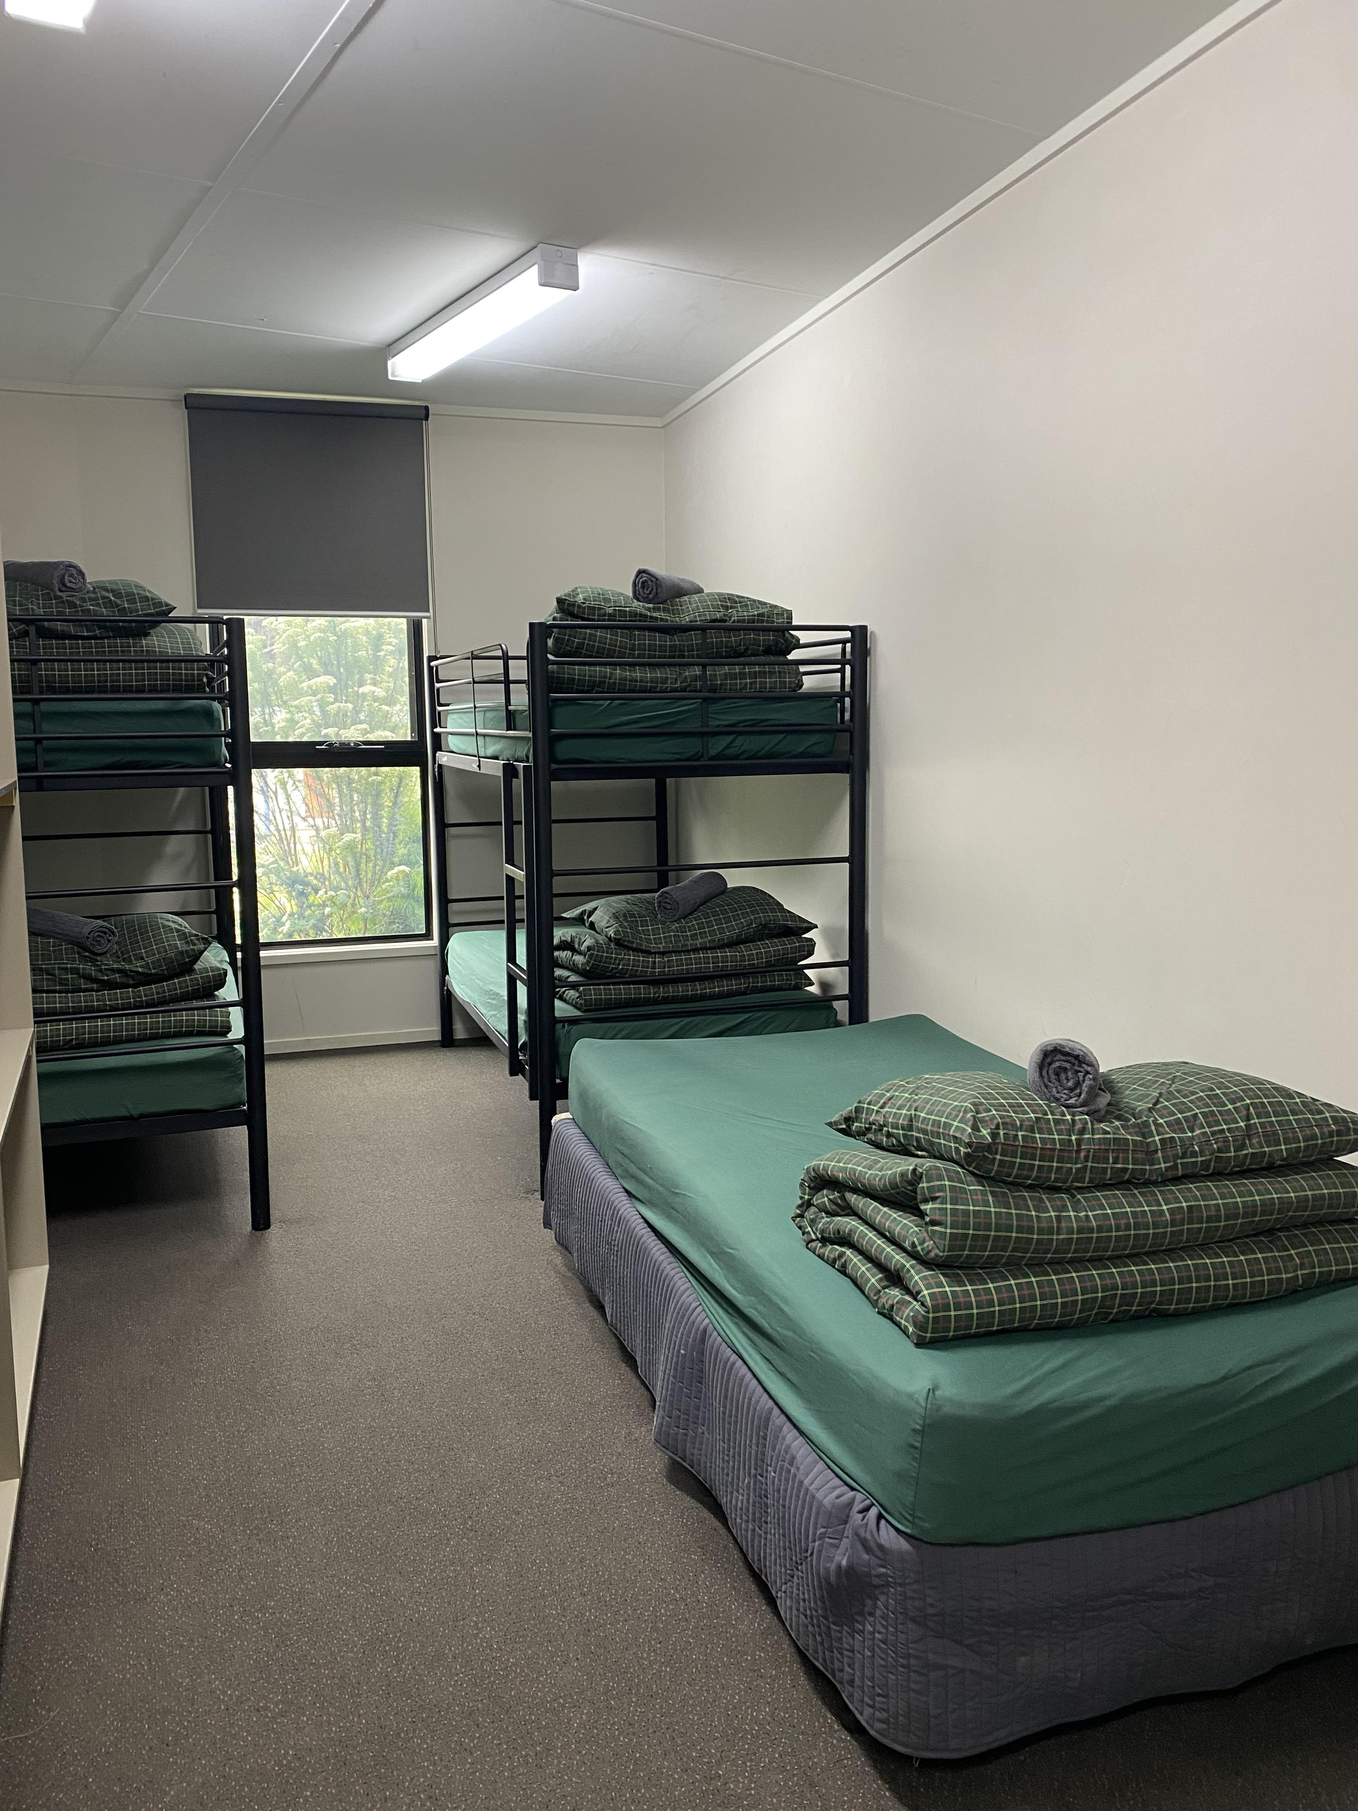
inside with linen

Room Amenities
- There is contrast between the walls, skirtings, floor and furniture
- There is a clear path through the room
- The edges of all furniture and fixtures are rounded
- Doors open fully against the adjoining wall
- There is a clear opening at least 850mm wide
- There luggage racks for at least two suitcases
- There is at least 850mm clear space beside the bed
- The bed height is no higher than 680mm from the floor
- Blocks are available to put under the bed legs

Bathrooms
The bathrooms have the following facilities/amenities in place
- All heating appliances and hot water pipes are protected or insulated
- All shower, bath and basin taps are clearly differentiated between hot and cold
- Fixtures and fittings have rounded edges
- The hot water is thermostatically controlled to 41 degrees
- The door is at least 850mm wide
- The width beside the toilet is 750.
- Handrails are fitted
- There is a minimum of 1400mm of clear space in front of the toilet
- The toilet seat is a contrasting colour to the floor
- The toilet seat is 460mm above the floor
- There is a roll-in shower with fold down fixed seat or a shower chair
- There is a portable shower head on flexible hose
  - Bathroom Image(s)
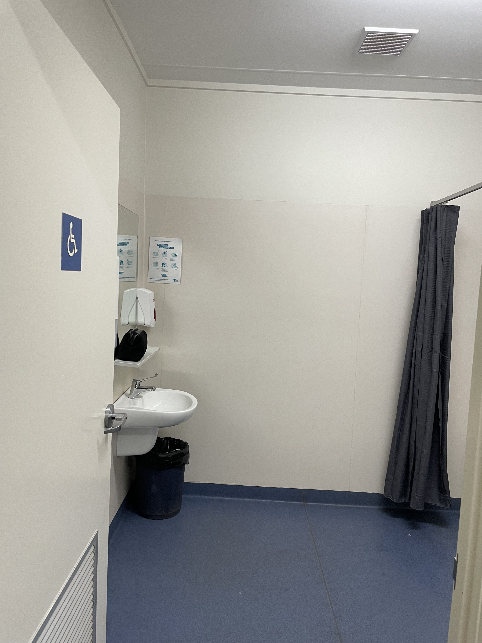
IMG_6383
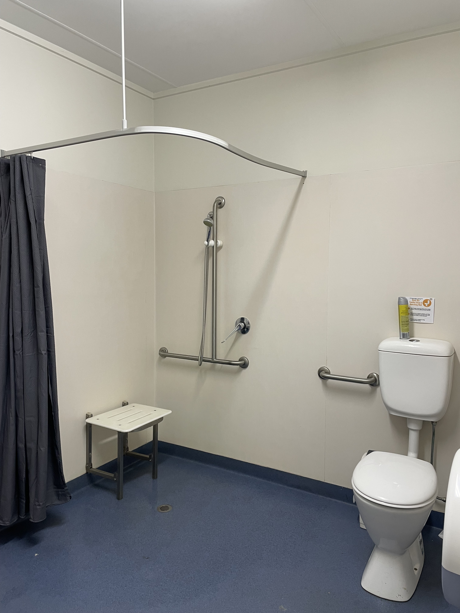
IMG_6382

COMMON AREAS

Parks and gardens
- The following parks and gardens amenities are available
- Accessible toilets
- Seats are provided at regular intervals
- Accessible picnic tables
- Accessible drinking fountains
  - Parks and Gardens Access/Entry Image(s)
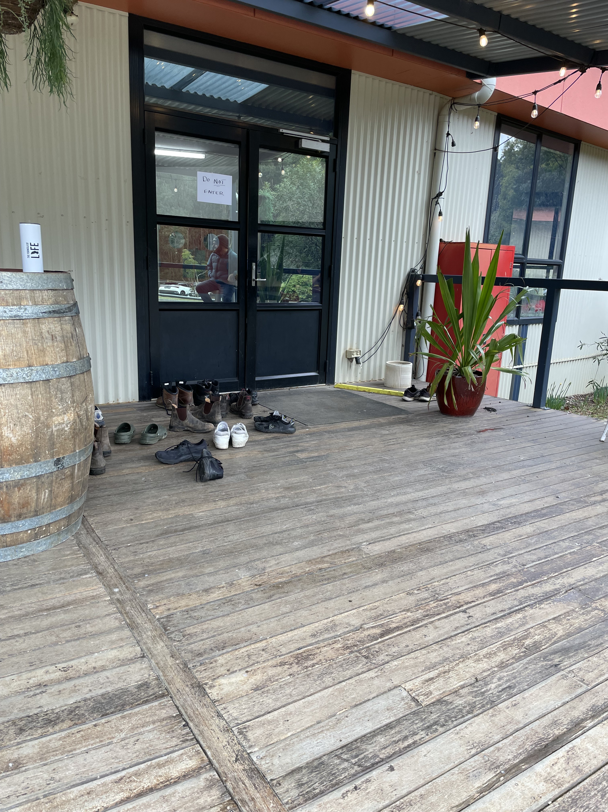
IMG_6387
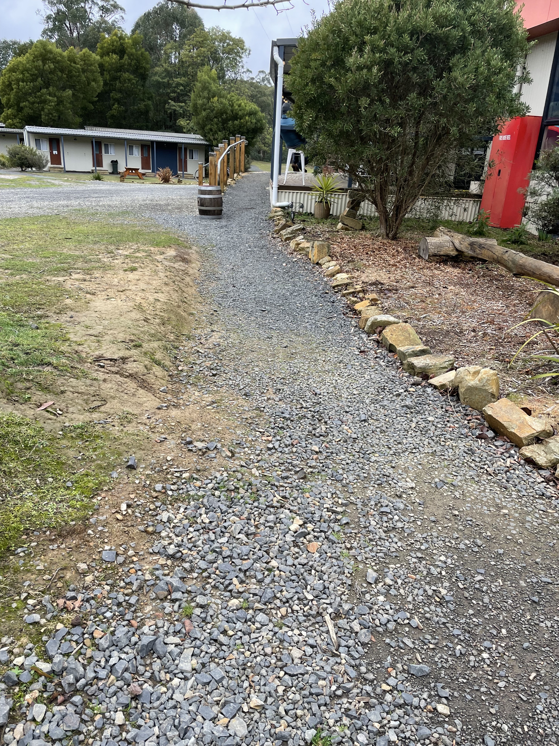
IMG_6386
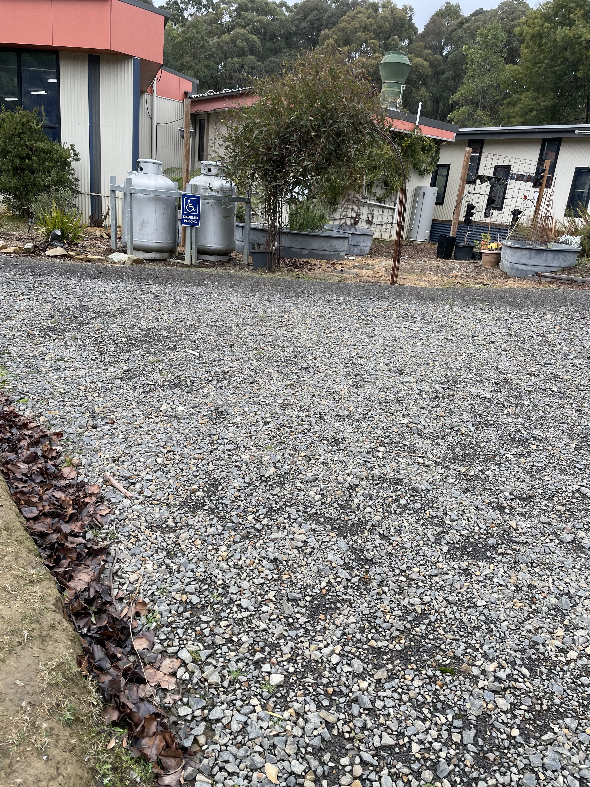
IMG_6384
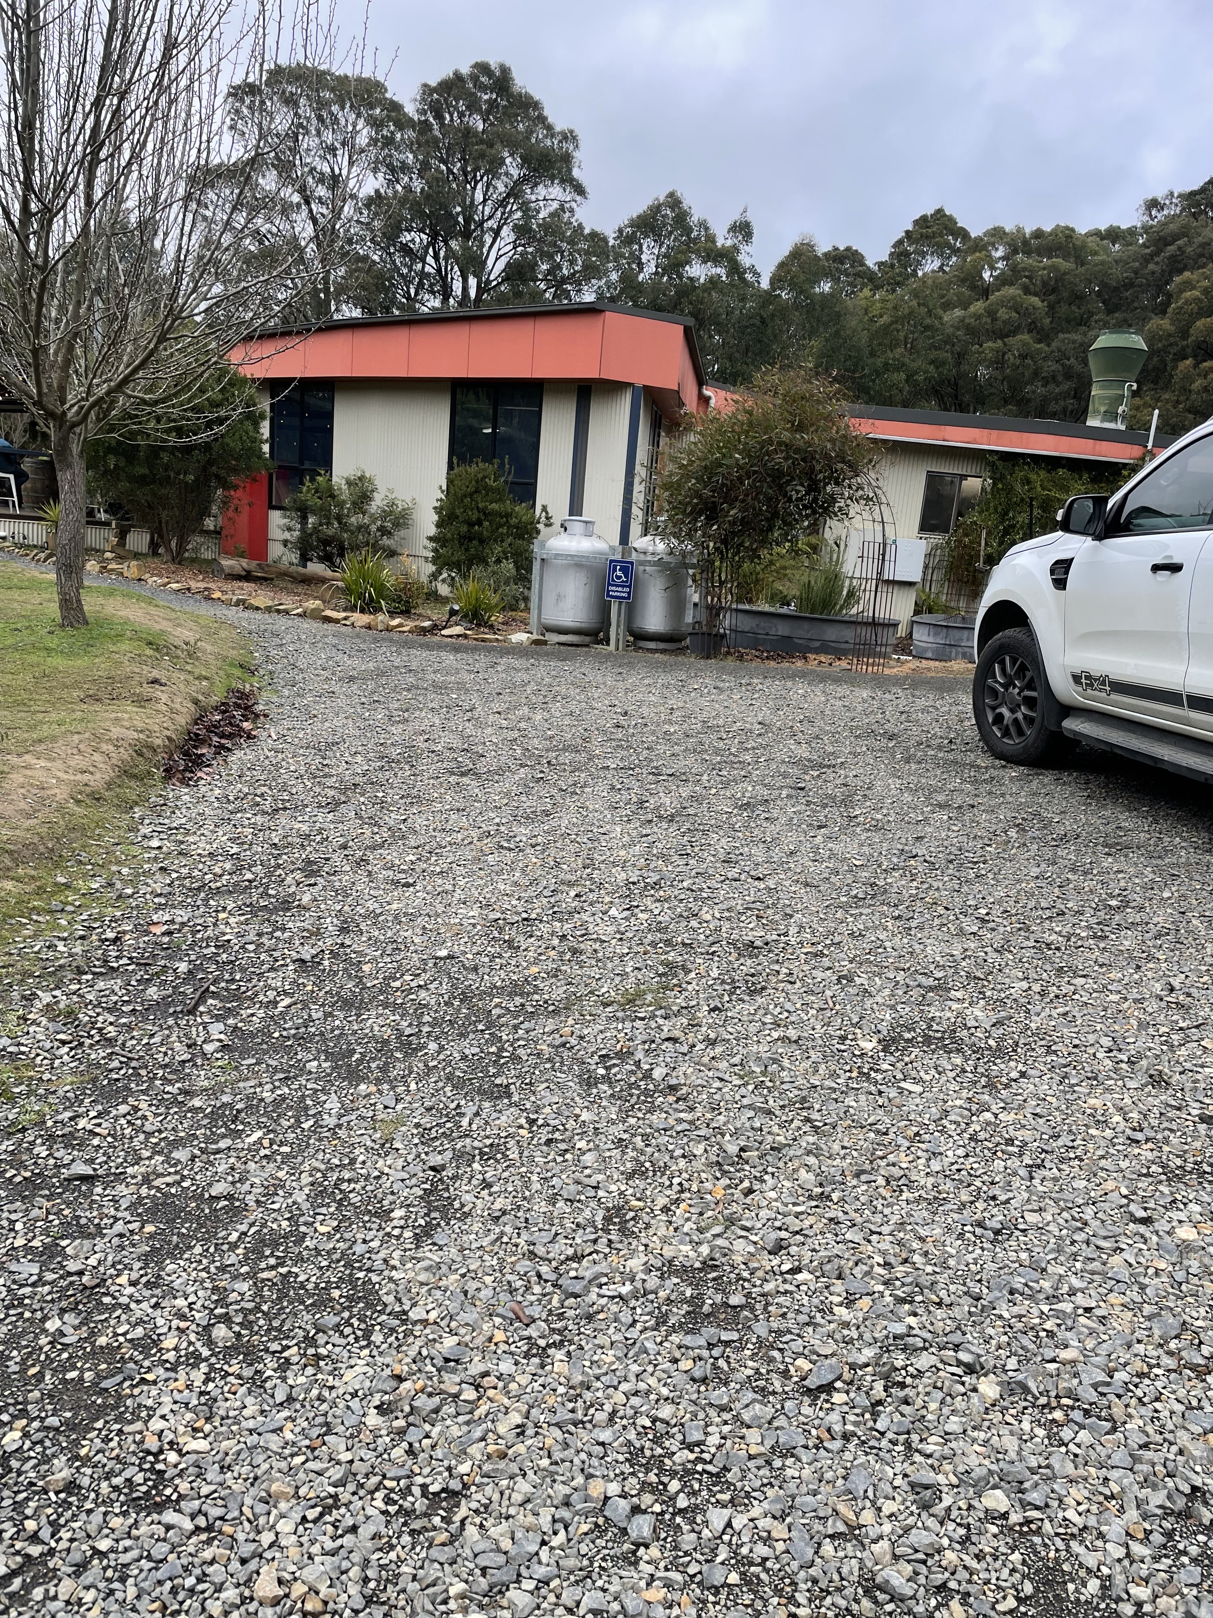
IMG_6385
- Handrails and stairs are built as per state/territory building code.
- A handrail is available and at 865-965mm in height.
- The handrail is continuously graspable along entire length at least one side.
  - Parks and Gardens Stair entry and exit Image(s)
IMG_6386

FOOD AND DRINK

Dining Spaces
The dining spaces have the following facilities/amenities in place
- The entrance has level access
- The doorway is at least 850mm wide
- There is level access through the dining area
- Chairs are moveable to allow for wheelchairs to be seated at the tables
- All glass doors and full height windows have contrast markings
- There are areas of full lighting
- There is an accessible toilet

Our business caters for the following dietary requirements
- Sugar free (diabetic)
- Gluten free (celiac)
- Lactose free (dairy free)
- Nut free
- Vegetarian
- Vegan
- Kosher
- Halal
- In addition, the following further information can assist guests:
Seperate cooking utensils/pot/pans are used for all dietary requirements
- There is a sample menu available online
Sample menu is available here -
www.kfacamp.com.au
  - Food and Beverage Image(s)
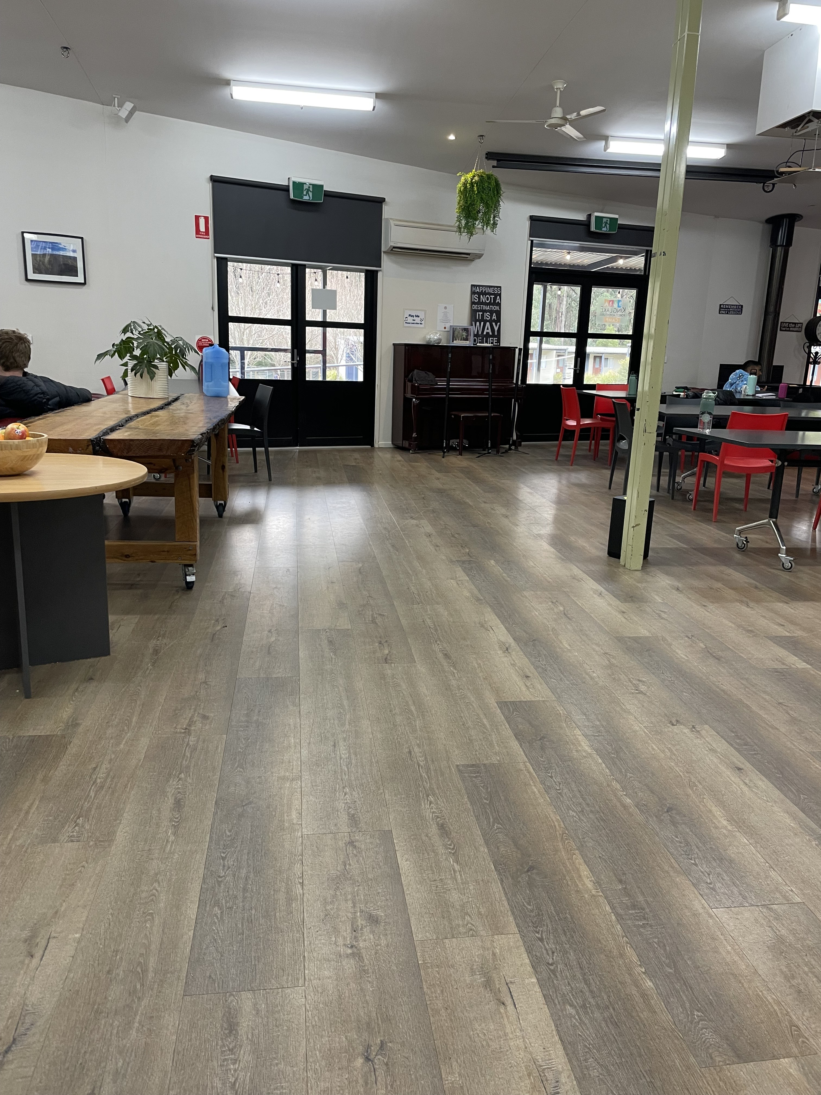
IMG_6389
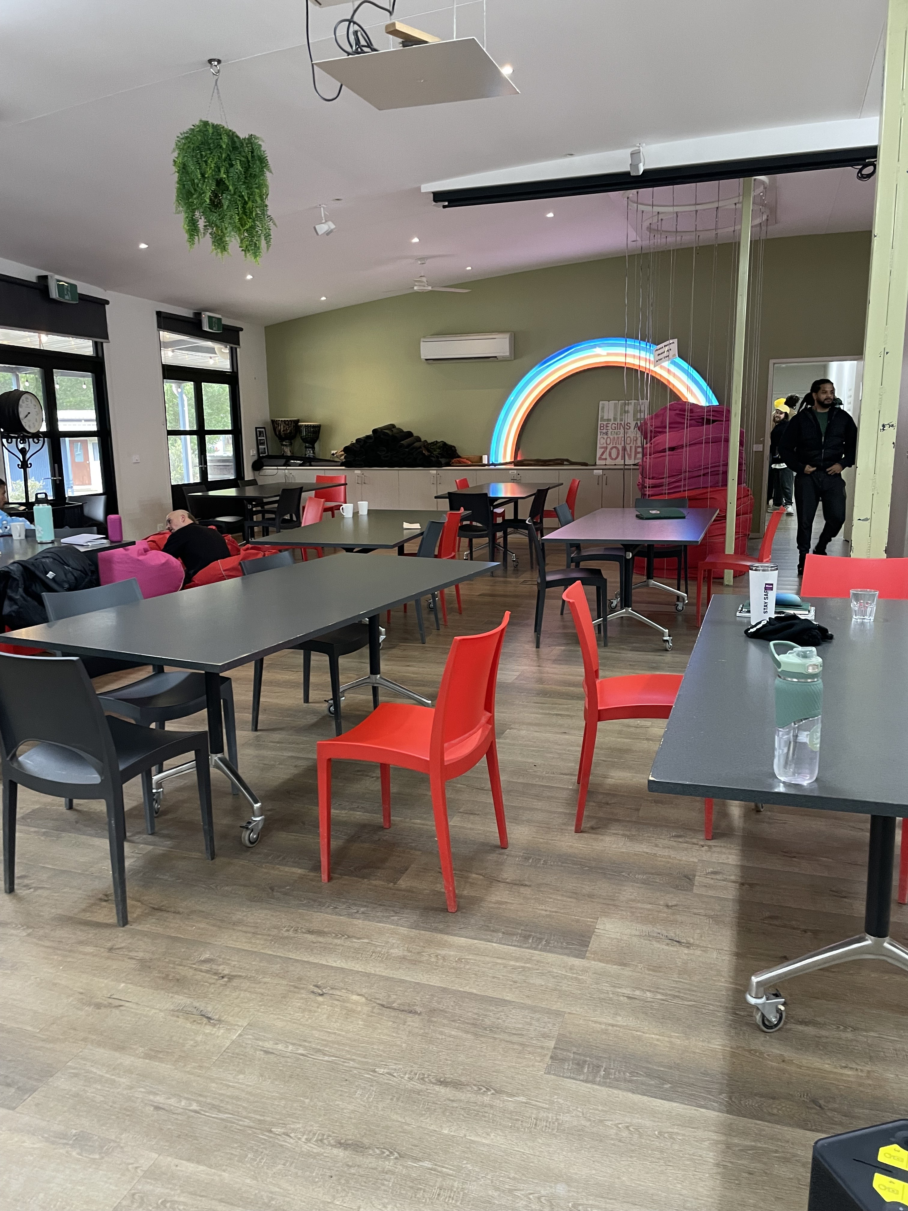
IMG_6390
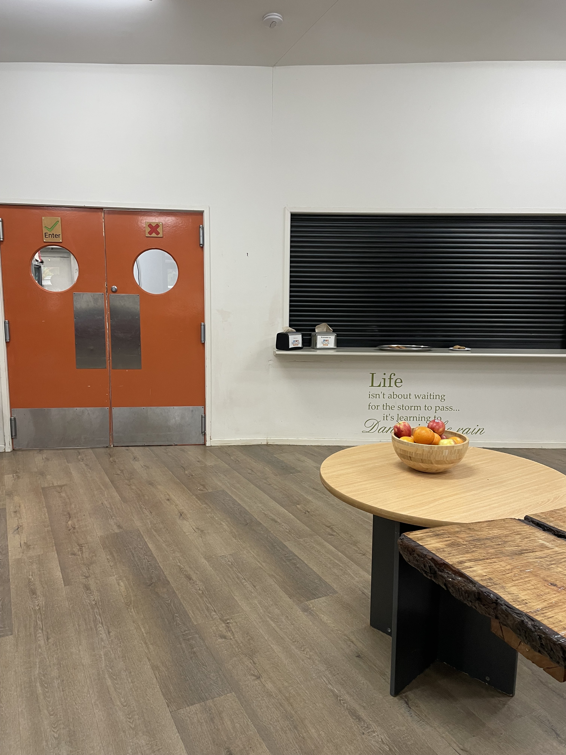
IMG_6391

ADVENTURE ACTIVITIES

Report Disclaimer
Please note that this business report, provided as a result of the use of the diagnostic assessment, is for information purposes only.
Australian Tourism Industry Council (ATIC) cannot guarantee the accuracy of respondent’s answers, or that they are fully representative of your business. Therefore, ATIC does not warrant or guarantee any particular outcome in respect of your businesses self-assessment.
This report is intended as guidance only for your business and should not be relied on for future marketing considerations. ATIC recommends that you seek your own independent advice as well as the results from the diagnostic.
Links to external web sites are inserted for convenience and do not constitute endorsement of material at those sites, or any associated organisation, product or service.
ATIC does not:
- Assume any legal liability for the accuracy, completeness, or usefulness of any information from this report or any links provided; or
- Accept responsibility for any loss associated directly or indirectly from the use of this report.

